CA-2

EDA PROJECT

* UNIVARIATE ANALYSIS
* BIVARIATE ANALYSIS
* STATISTICAL INTUITION

SUBMITED BY: AMARDEEP SINGH

REG: 12006933

ROLL NUM: 52

SECTION: K20CH

**Data Preparation**

Importing Data:

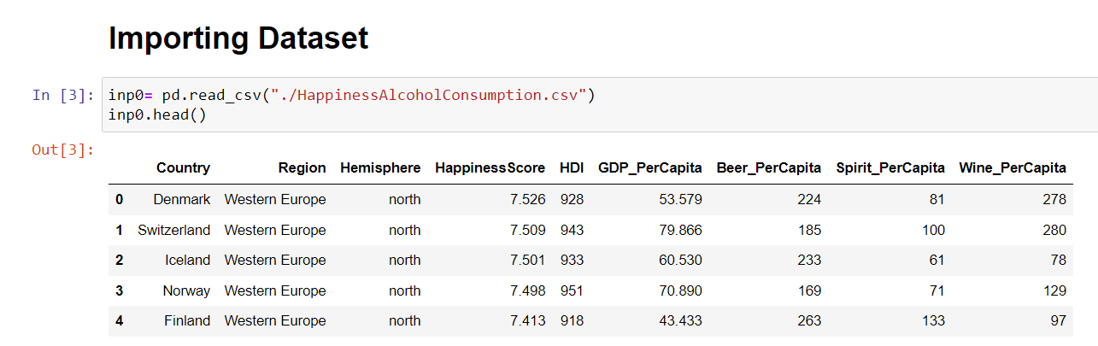

Disclamier**:**

*Column GDP_PerCapita in our dataset is incorrect. So we will be replacing that column with another dataset's column GDP.*

Importing another dataset for gdp values from 2018

**Merging and renaming**

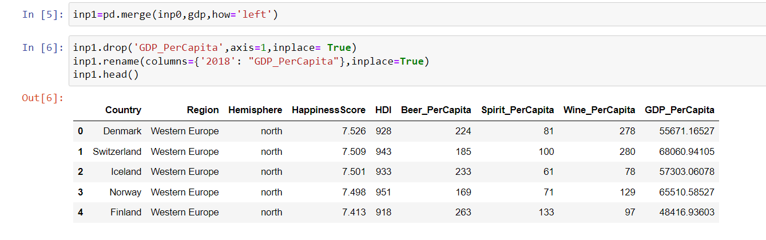

**Cleaning Dataset**

We have got a few null values. Let’s check where they are.

Now after finding these values from google

1. Venezuela=3534
2. Slovakia= 19389.98
3. Syria= 1265.61[¶](http://localhost:8888/notebooks/PycharmProjects/Machine%20Learning/EDA%20Project/cse%20353%20ca2.ipynb#Syria=-1265.61)

**Lets fix them**

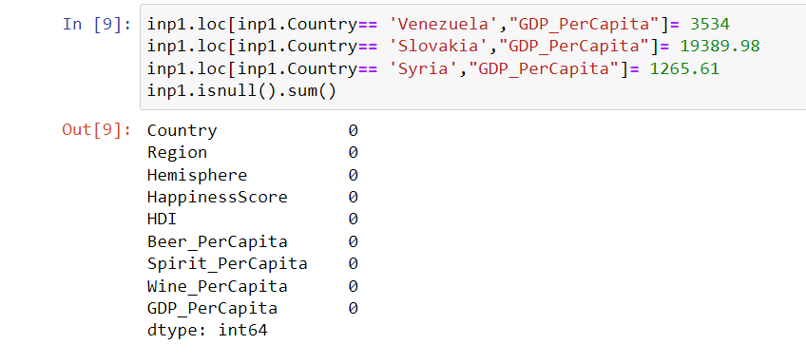

**Lets look for logically null values or outliers**

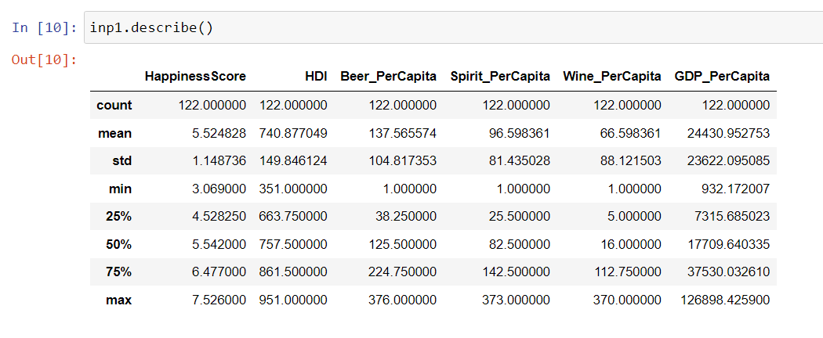

As all of these countries' data is important, we can’t rule out them.

To avoid further issues we will work mostly on percentiles and medians

**Univariate Analysis**

1. **Region**

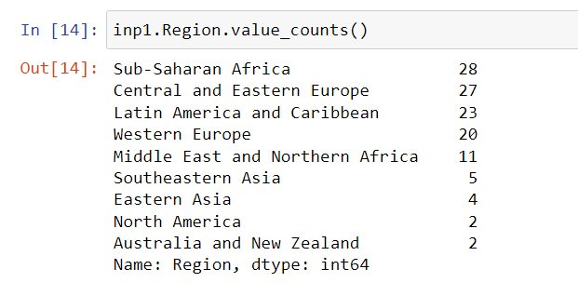

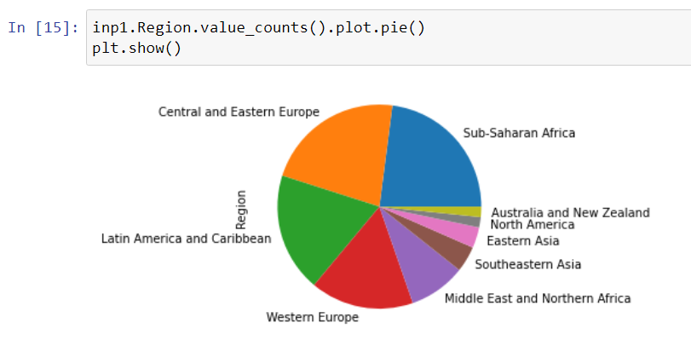

1. **Hemisphere**

Some Values are incorrect, lets fix them.

1. **Happiness Score**

1. **HDI (Human Development Index)**

Checking for data distribution

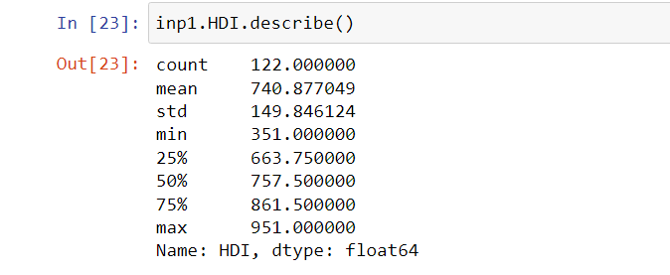

Boxplot to check outliers and data distribution

Highest Human Development Index

Lowest Human Development Index

1. **Beer , Spirit, Wine per capita**

Beer:

Checking for data abnormalities and other statistical data

Spirit:

Checking for data abnormalities and other statistical data

Wine:

Checking for data abnormalities and other statistical data

Lowest Consumption of these beverages

Heighest Consumption of these beverages

1. **GDP per capita**

**Heighest:**

**Lowest:**

1. **Overall Alcohol Consumption**

Let’s add a column "Alcohol" that will simplify our analysis

Alcohol = (Beer + Spirit + Wine)

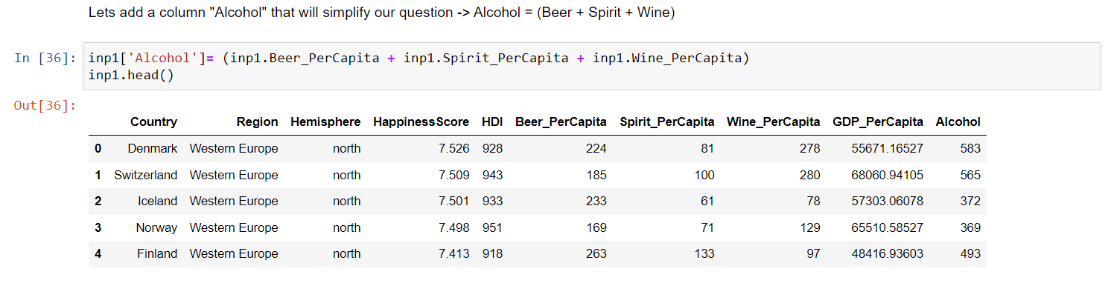

These countries drink alcohol the most.

These countries drink alcohol the least.

1. **Happiness Category**

To simplify our analysis, we will make a new category HappinessCat, and divide happiness score based on persentiles.

**Bivariate Analysis**

1. **Happiness vs HDI**

**Line plot**

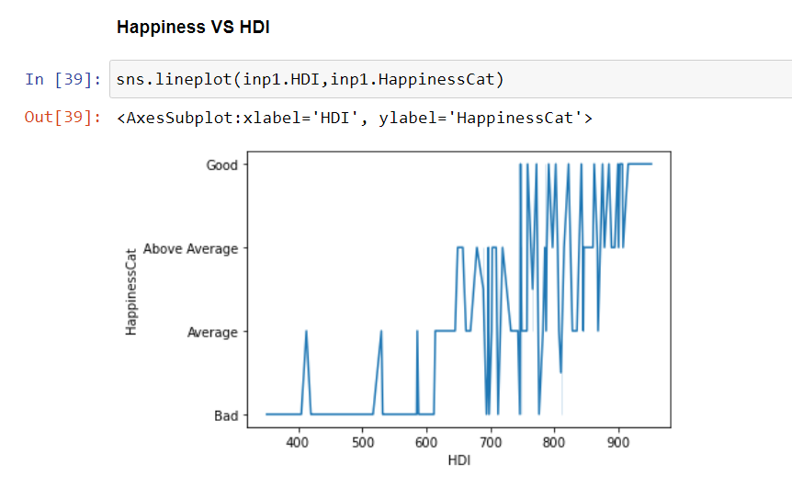

**Bar plot**

This graph somewhat tells developed countries are mostly happy. Whereas mostly underdeveloped countries have low happiness score.

1. **HDI VS Alcohol**

**Line plot**

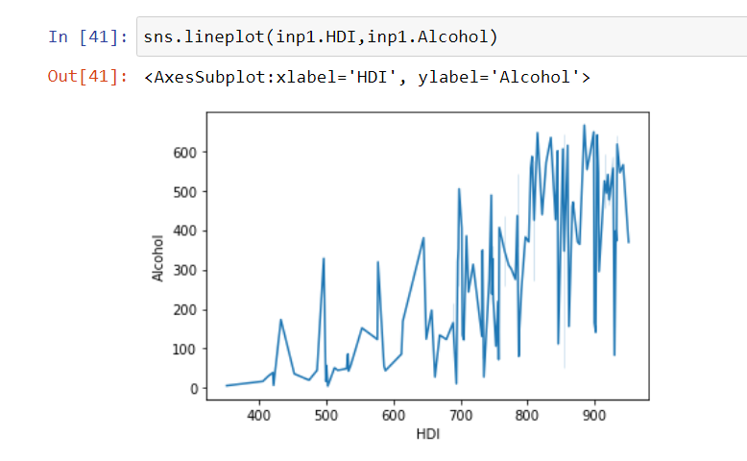

**Scatter plot**

Not much is clear here, but we can see, developed countries consumes more alcohol than underdeveloped ones[**.**](http://localhost:8888/notebooks/PycharmProjects/Machine%20Learning/EDA%20Project/cse%20353%20ca2.ipynb#Not-much-is-clear-here,-but-we-can-see,-developed-countries-consumes-more-alcohol-than-underdeveloped-ones)

More will be revealed in further multivariate analysis.

1. **Happiness vs Alcohol**

**Bar Plot**

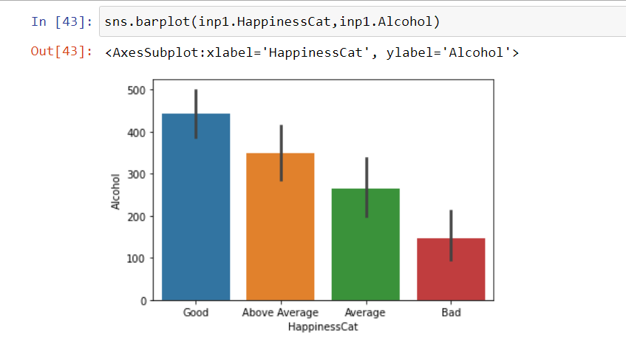

**Line Plot**

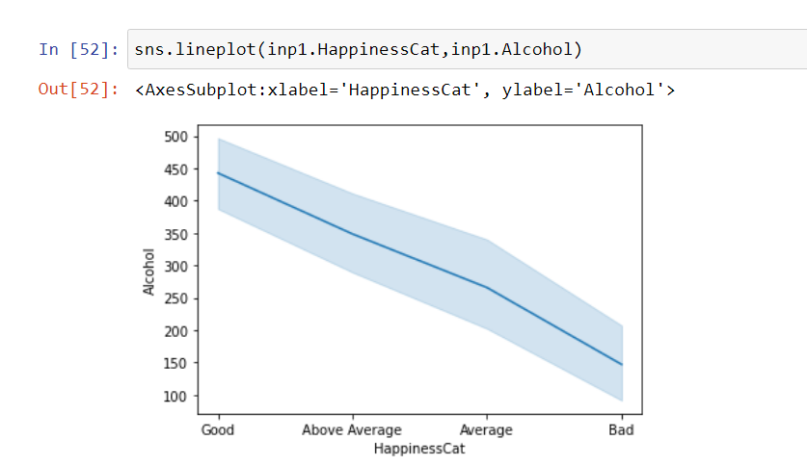

Here we are getting a bit of hint that happiest countries usually consume more alcohol.

1. **GDP per capita vs Happiness**

**Bar Plot**

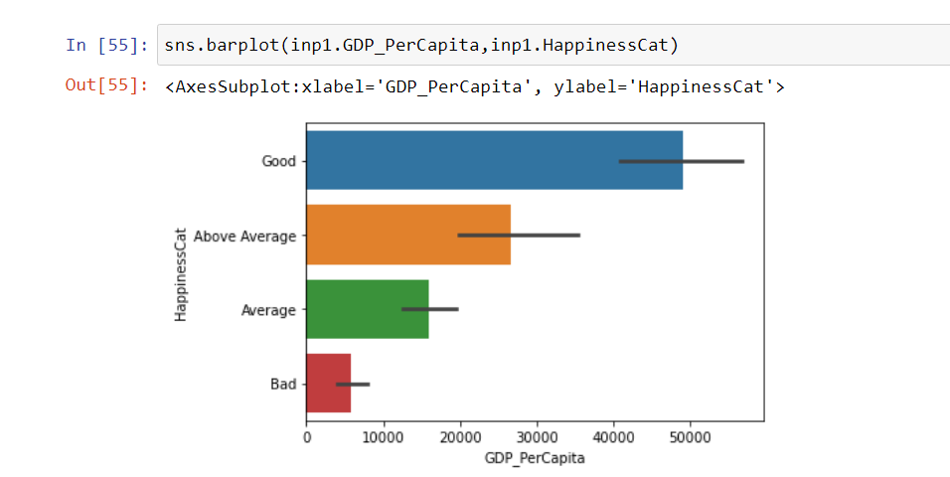

Better GDP per capita means happier people, happier nation.

**Statistical Intuition**

**Mean:** Average of all the columns respectively.

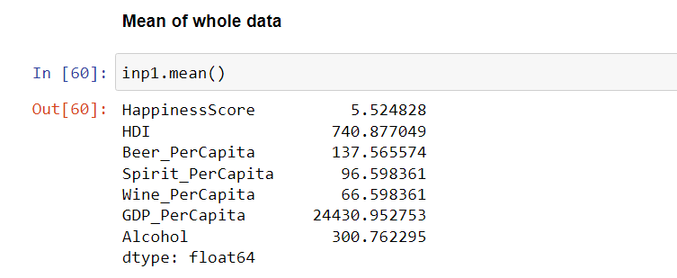

**Median:** Centre of all the columns respectively.

**Standard Deviation:**

**Variance:**

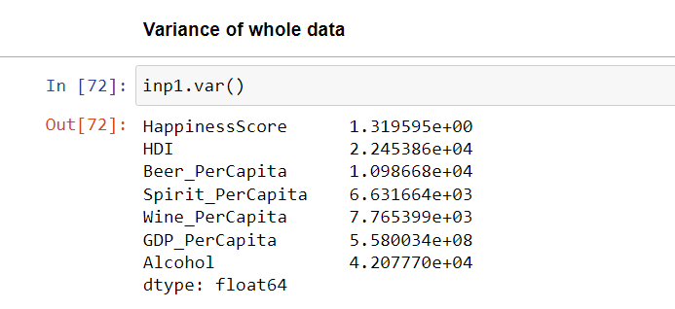

**Percentile Division:**

